Examples of pre-processing: identification of binding energy range

XPS spectra already analyzed:

Cacovich, S., Messou, D., Bercegol, A., Béchu, S., Yaiche, A., Shafique, H., Rousset, J., Schulz, P., Bouttemy, M., & Lombez, L. (2020). Light-induced passivation in triple cation mixed halide perovskites: Interplay between transport properties and surface chemistry. ACS Applied Materials and Interfaces, 12(31), 34784–34794. <https://doi.org/10.1021/acsami.0c06844>

I 3d and Pb 4f spectra for MAPbI3 material:

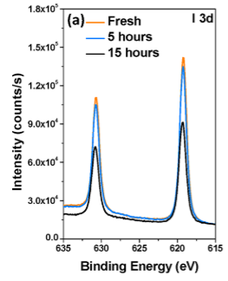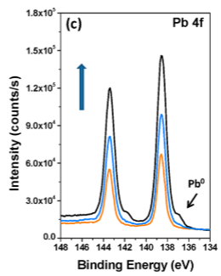

@ 631 eV: I 3d 3/2 @ 143.5 eV: Pb 4f 5/2

@ 619 eV: I 3d 5/2 @ 138.5 eV: Pb 4f 7/2

Are these measurements realistically comparable to the TRXPS measurements? Similar chemical environment for lead and iodine?

**Identification of proper kinetic / binding energy range in TRXPS measurements:**

* Considered that TRPES matrices contain data with **increasing order** in terms **of kinetic energy**: therefore, decreasing order for binding energy.
* Identified ranges according to information in Tempo_July_2023.xlsx, sheet “calcul KE”:

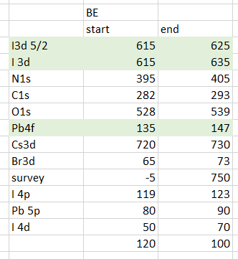

* For 2023 measurements, core levels are identified as:
  + Pb 4f: BE ranges from 135 to 147 eV
  + I 3d 5/2: BE ranges from 615 to 625 eV
  + I 3d (only NREL 4): BE ranges from 615 to 635 eV
* For 2021 measurements, core levels are identified as:
  + Pb 4f 7/2: used same BE range as 2023 measurements (named “Pb 4f”) but results show two peaks, not only Pb 4f 7/2.
  + I 3d 5/2 used same BE range as 2023.

# Four measurements from 2021 session:

Measurement 2: Measurement 9:

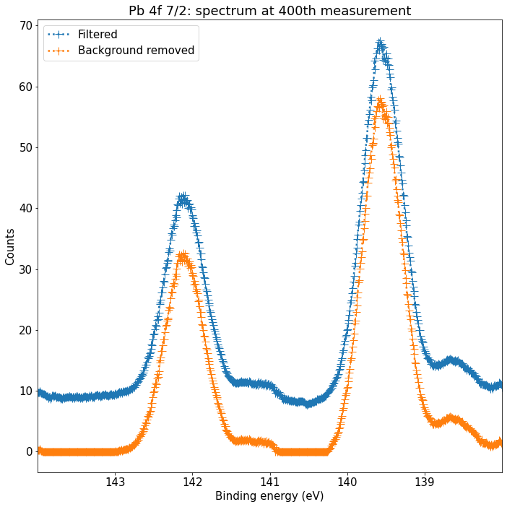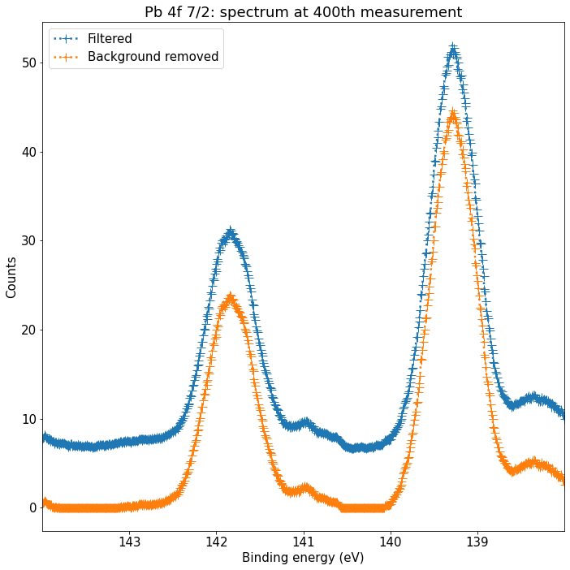

@ 142.5 eV: Pb 4f 5/2 @ 142 eV: Pb 4f 5/2

@ 139.5 eV: Pb 4f 7/2 @ 139 eV: Pb 4f 7/2

Measurement 3: Measurement 4:

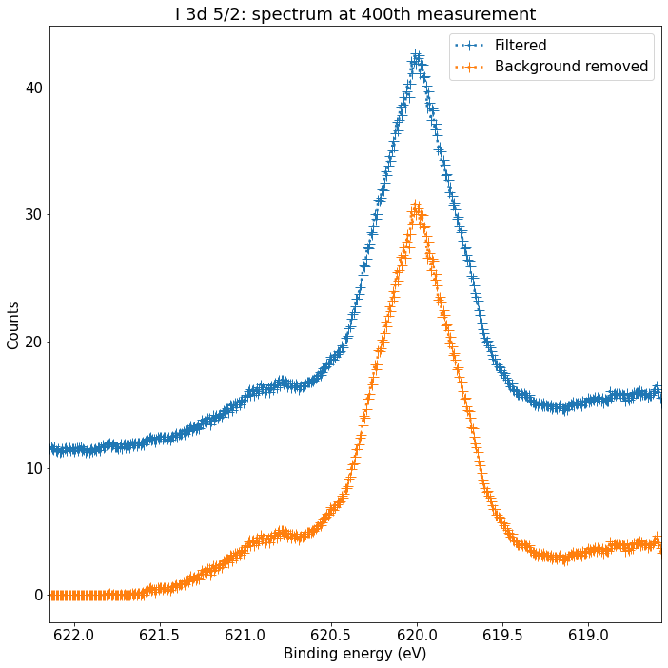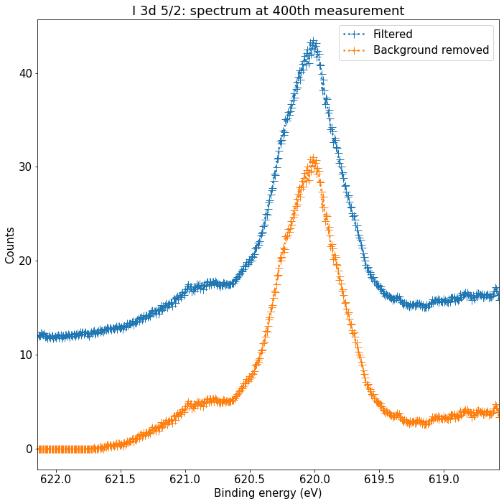

@ 620 eV: I 3d 5/2 @ 620 eV: I 3d 5/2

“shape” of the background (decreasing with higher energies) seems wrong.

# Four measurements from 2023 session:

Measurement 19: Measurement 20:

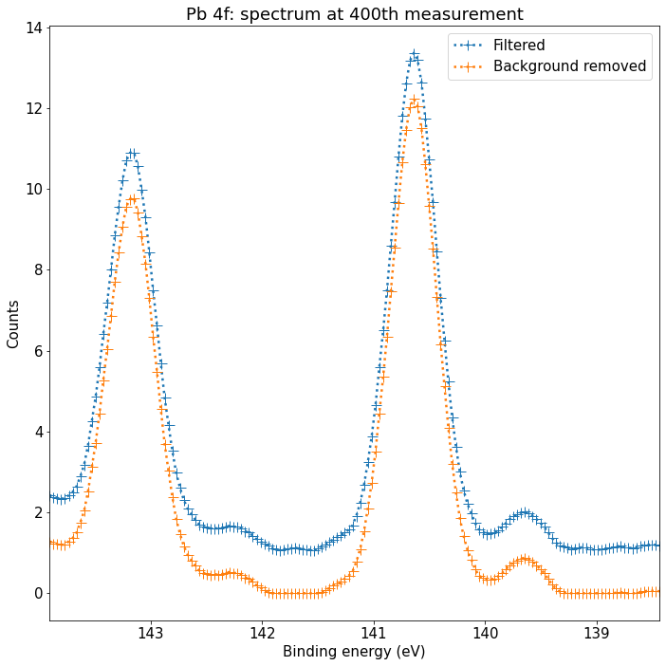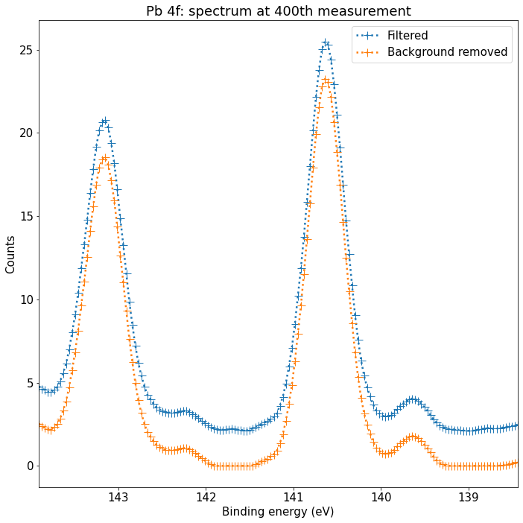

@ 143.5 eV: Pb 4f 5/2 @ 143.5 eV: Pb 4f 5/2

@ 140.5 eV: Pb 4f 7/2 @ 140.5 eV: Pb 4f 7/2

Measurement 27: Measurement 28:

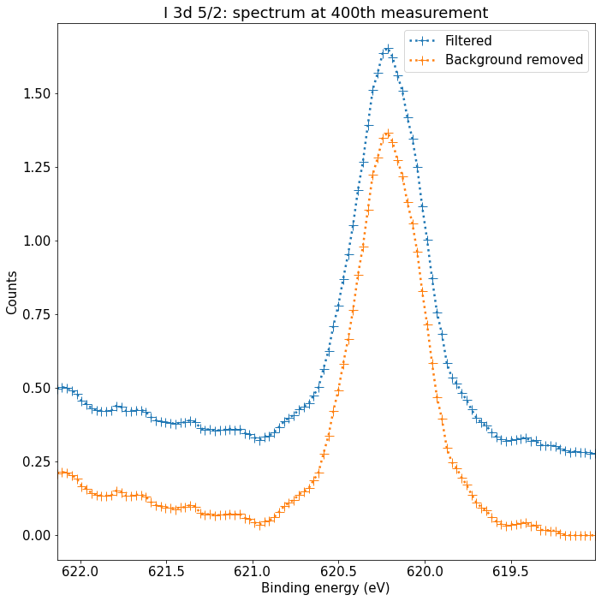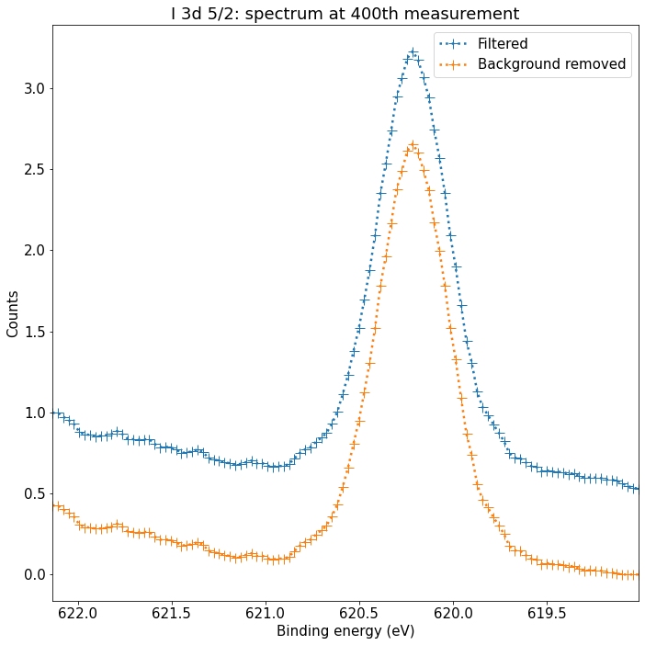

@ 620.25 eV: I 3d 5/2 @ 620.2 eV: I 3d 5/2

Measurement 99: Measurement 100:

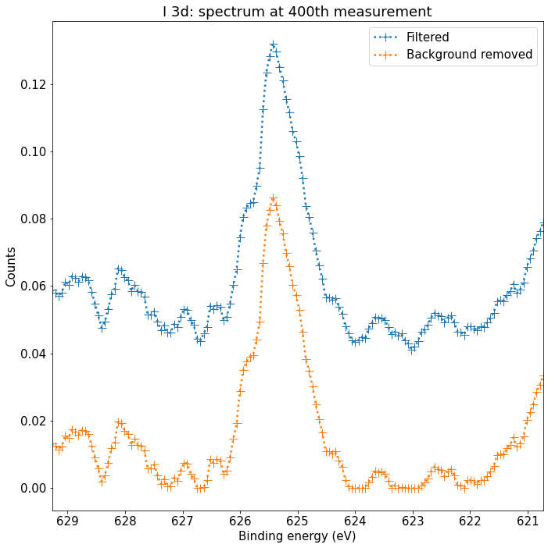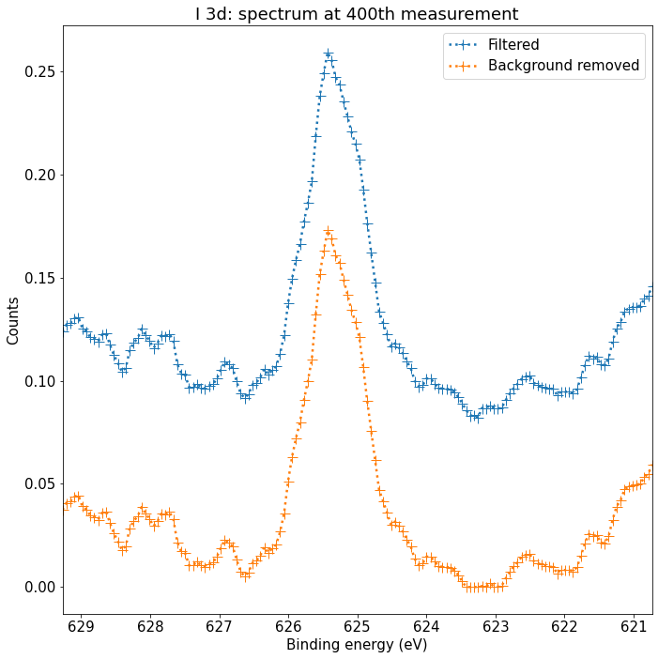

@ 625 eV: ? @ 625.5 eV: ?

Position of the peak at 625 eV seems wrong.

Same measurements, but BE range is taken as the same as other iodine measurements, identified as I 3d 5/2:

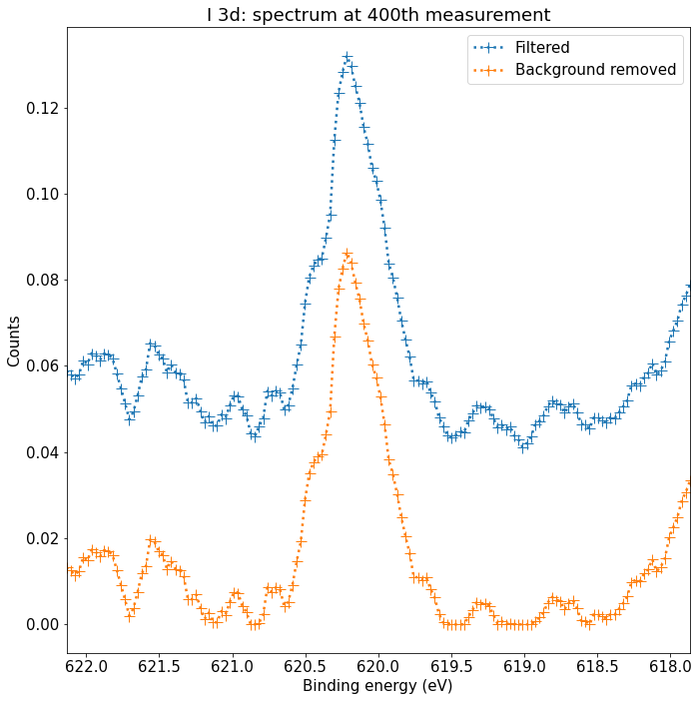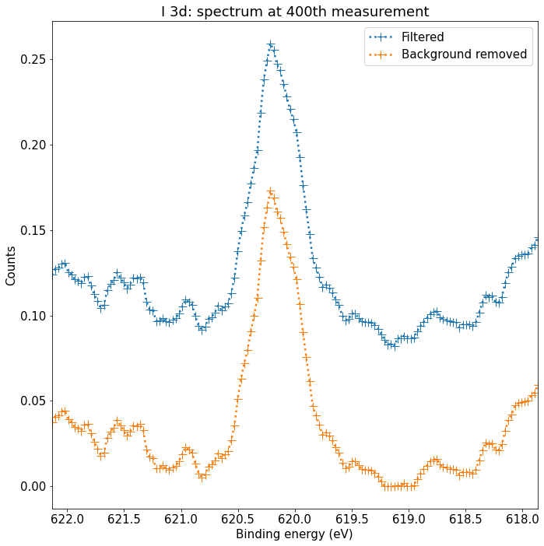

The peak is now at around 620 eV, which is more coherent.

# Procedure to define proper binding energy range:

**Context:**

Photo-electron analyzer is composed of electron optics, a magnetic field deviating the electrons and a position sensitive detector.

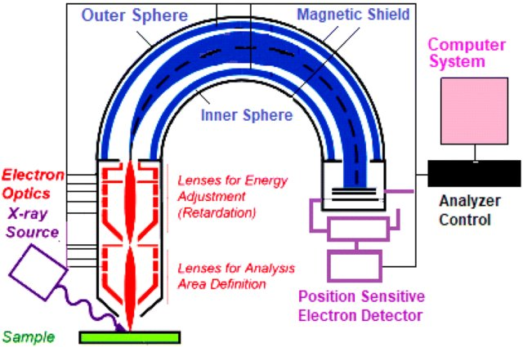

Only a specific energy range is “imaged” on the position detector. This range vary from experiment to experiment.

The width of the probed energy range is always the same, but unknown.

For a given experiment we only have the energy value at the center of the position detector.

**Procedure:**

Use Pb 4f measurements, where distance between 5/2 and 7/2 is known to be 4.8 eV

Examples:

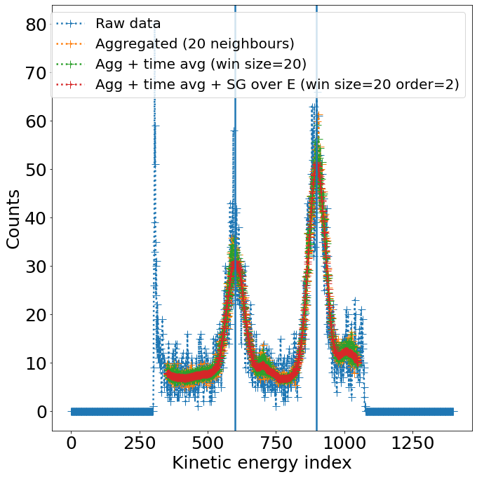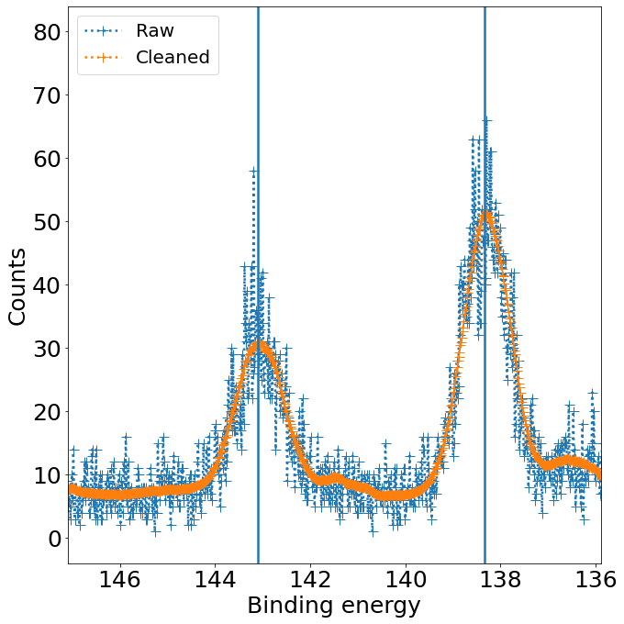

measurement_i: 9

Energy resolution: 0.015982951518380393 eV/point

Pb 4f 7/2 peak: 138.3411107256382 eV

Pb 4f 5/2 peak: 143.10743479530817 eV

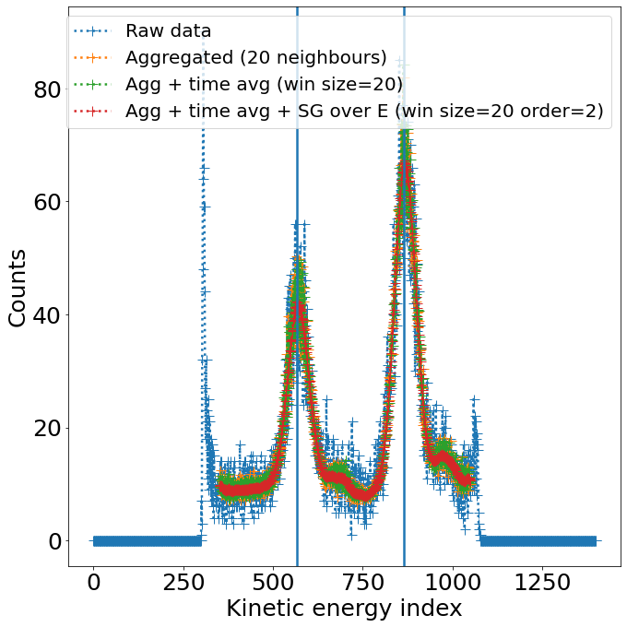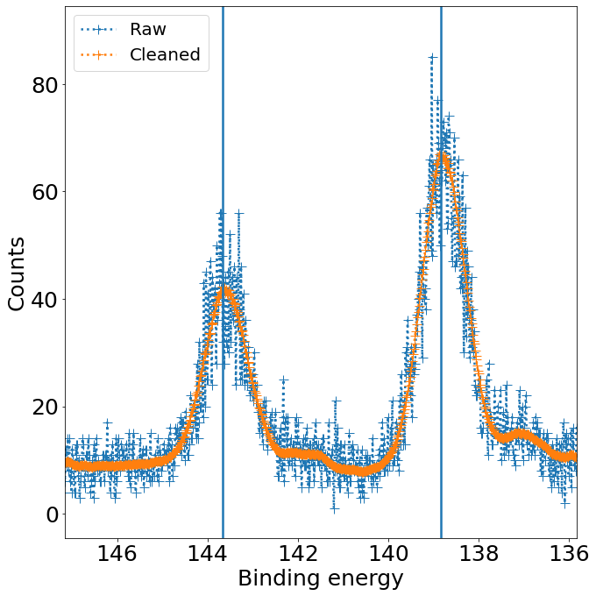

measurement_i: 2

Energy resolution: 0.016163793103448277 eV/point

Pb 4f 7/2 peak: 138.83915543121933 eV

Pb 4f 5/2 peak: 143.65940881417762 eV

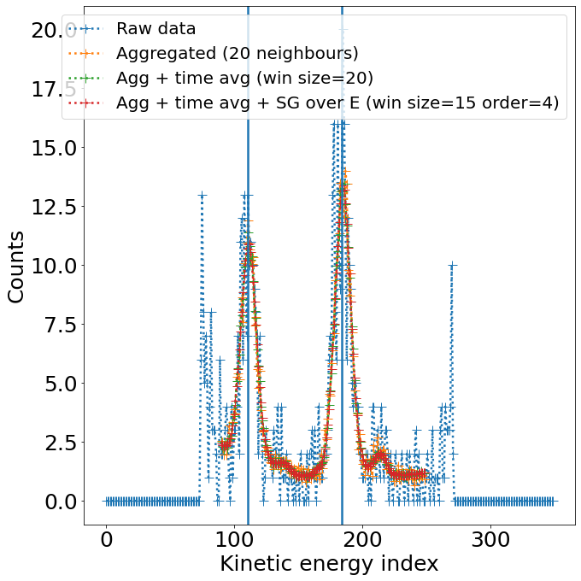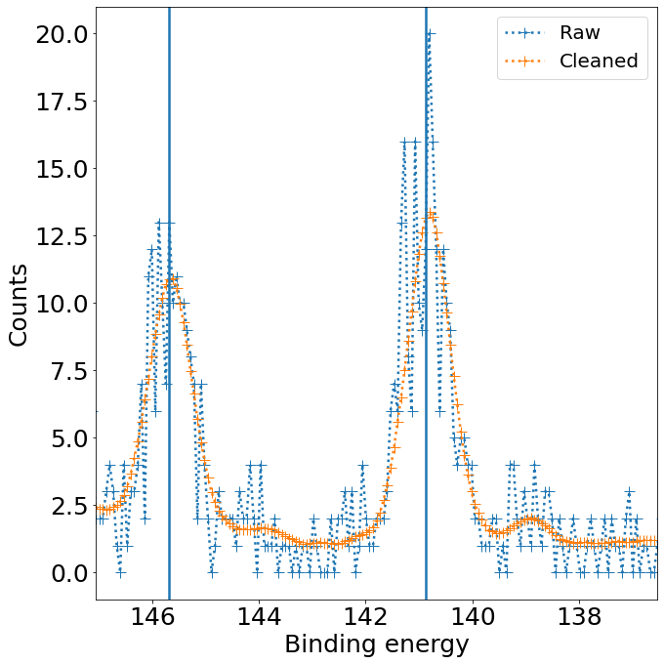

measurement_i: 19

Energy resolution: 0.06563653767263777 eV/point

Pb 4f 7/2 peak: 140.874666224179 eV

Pb 4f 5/2 peak: 145.67986260680337 eV

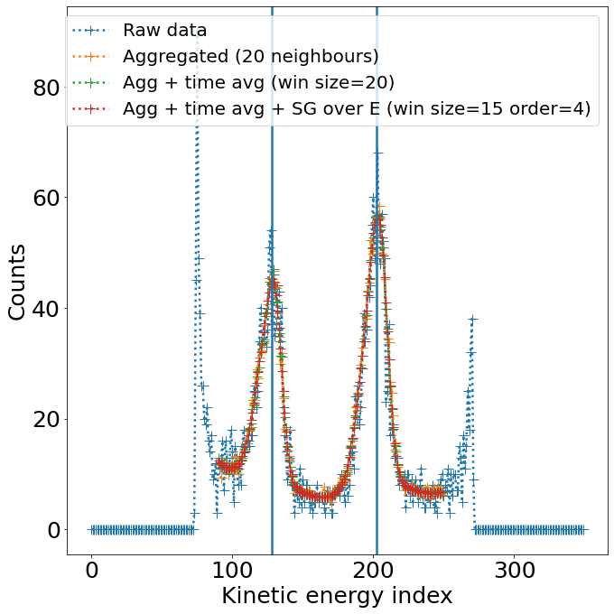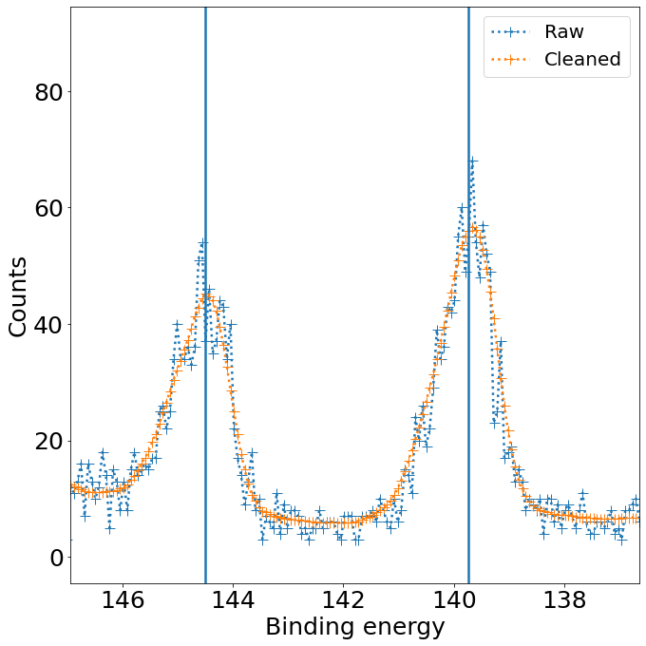

measurement_i: 31

Energy resolution: 0.06423982869379015 eV/point

Pb 4f 7/2 peak: 139.72834283330164 eV

Pb 4f 5/2 peak: 144.49571120914453 eV

I 3d and Pb 4f spectra for MAPbI3 material:



Sample CTF1:

MAPbI3, Thin film made of single crystal I2 environment: CTF1

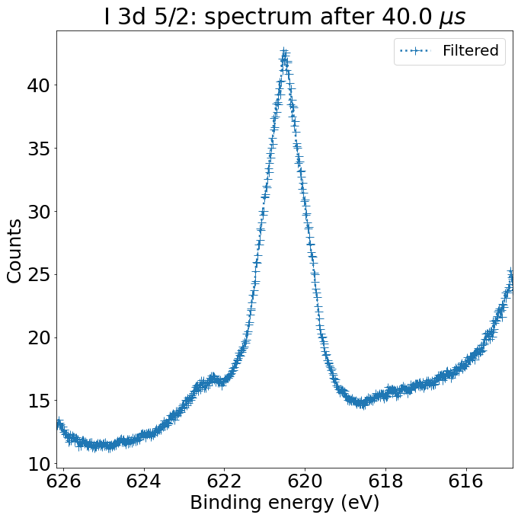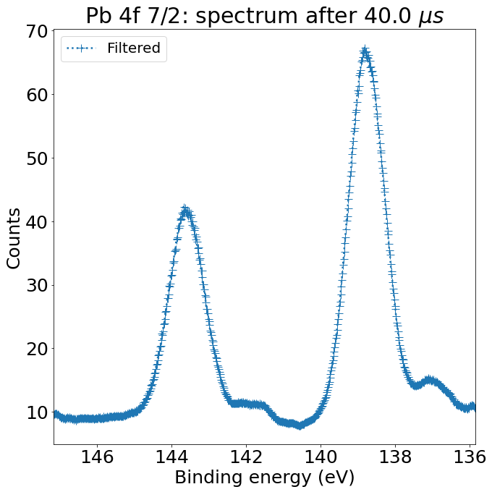

Tyree Energy Technologies Building, Kensington NSW 2033, Australie

Sample IWAN:

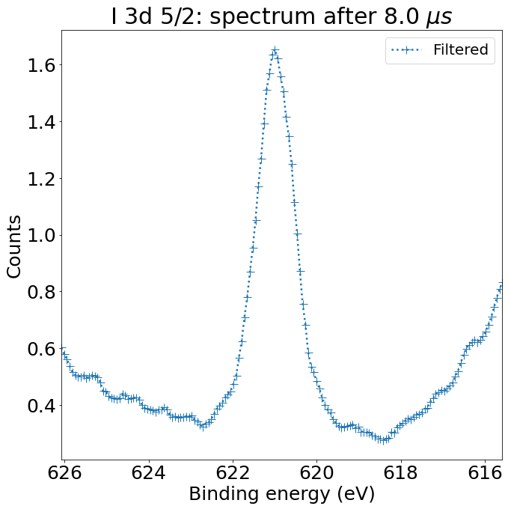 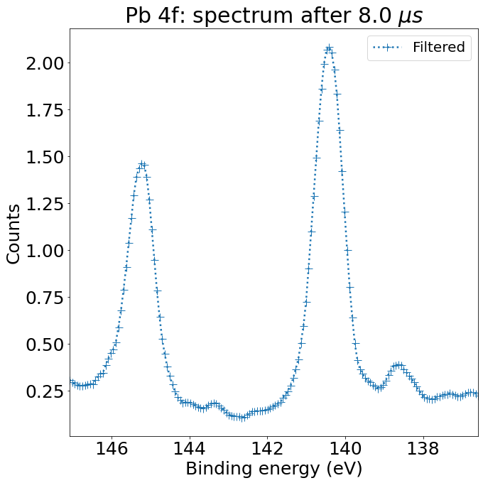

Sample NREL 1

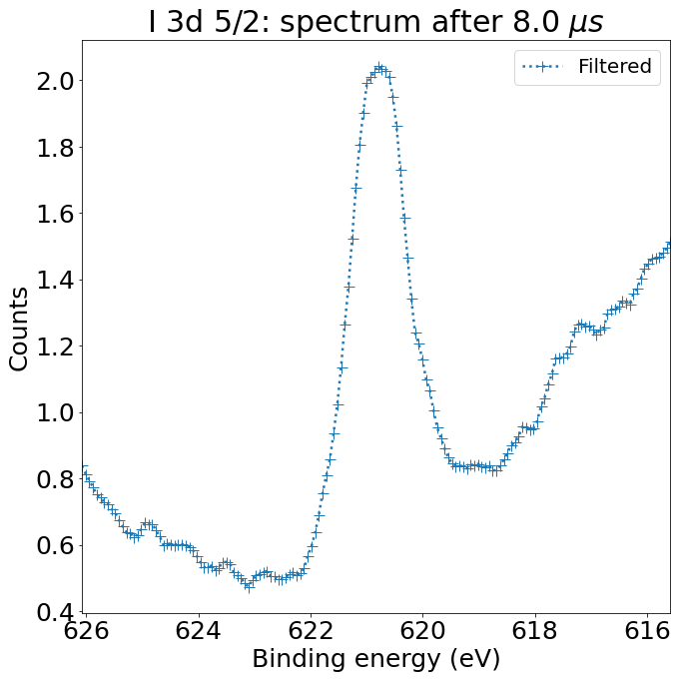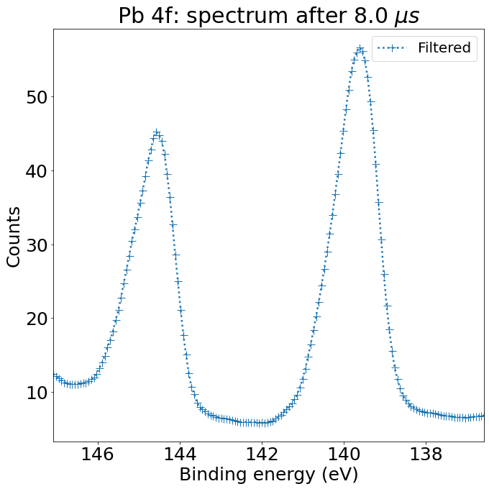

Sample NREL 3

